Advanced CSS and Sass

# How CSS Works

## Three pillars of writing good HTML and CSS.

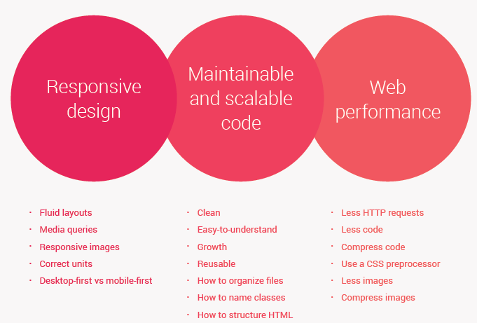

## What Happens To CSS When We Load Up A Webpage?

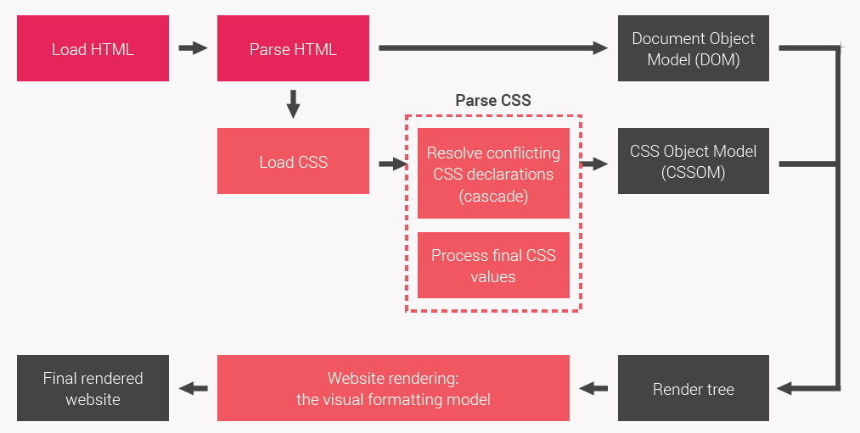

* The Process final CSS values step does for instance, converting a margin defined in percentage units to pixels.
* The Visual formatting Model algorithm calculates and uses a bunch of stuff that you already know about, like the box model, floats, and positioning.

## CSS Terminology

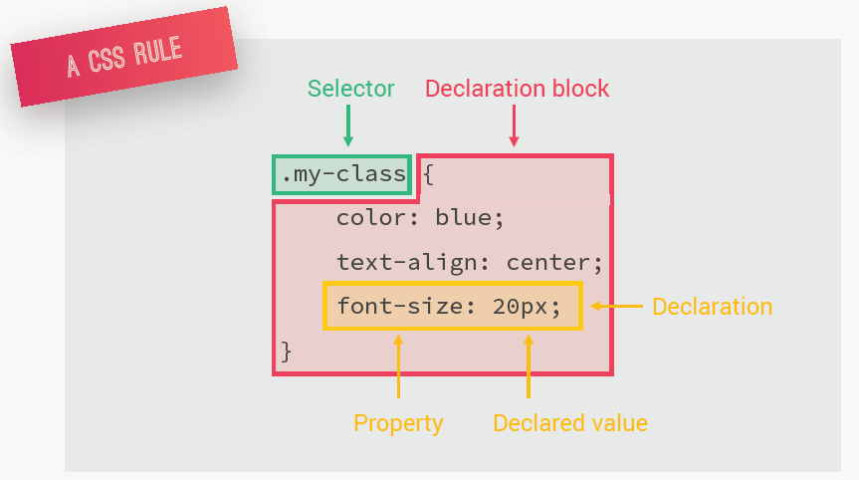

## How CSS is Parsed: Part 1 (Resolve conflicting CSS declaration Step)

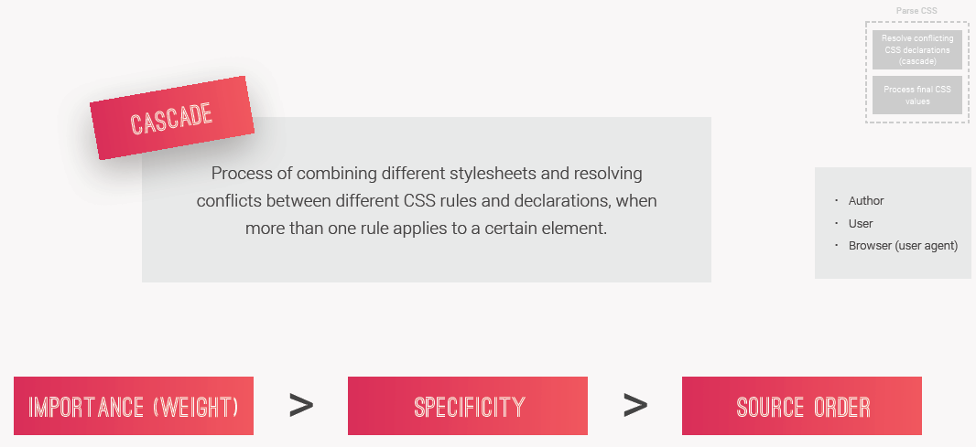

* Cascade is the process of combining different stylesheets and resolving conflicts between different CSS rules and declarations when more than one rule applies to a certain element.
* A CSS declaration for a certain style property like font size can appear in several stylesheets and also several times inside one single stylesheet.
* Also CSS can also come from different sources.
  + **Author** – The most common one is the CSS that we the developers write. These declarations that we put in our stylesheets. These are called the **author** declarations.
  + **User** **CSS** – which is CSS coming from the user. For instance, when the user changes the default font size in the browser.
  + **Default Browser (User Agent) CSS** – For instance, if we put an anchor tag in our HTML for a link and then don't style it at all, it will usually be rendered with blue text and underlined. That's called the user agent CSS, because it's set by the browser.
* The cascade combines the CSS declarations coming from all these different sources.

### How does the cascade actually resolve conflicts when more than one rule applies?

Cascade step uses below order to determine which CSS rule takes precedence.

1. Importance at the selector
2. Specificity
3. Sort order of the conflicting declarations

#### Importance

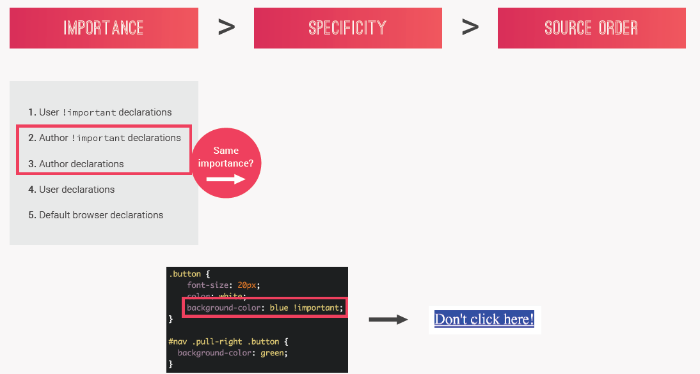

* First off the cascade starts by giving the conflicting declarations different importance's based on where they are declared, i.e. based on their source.
* The important declarations are the ones marked with the important keyword.
* Order from most important to least important declarations –

1. User !important declarations
2. Author !important declarations
3. Author declarations
4. User declarations
5. Default browser declarations

* E.g. As highlighted in above image the declaration with the blue background color contains the important keyword and therefore this declaration is more important. This means that this is the declaration that gets precedence and so we see that our button is indeed blue.

#### Specificity

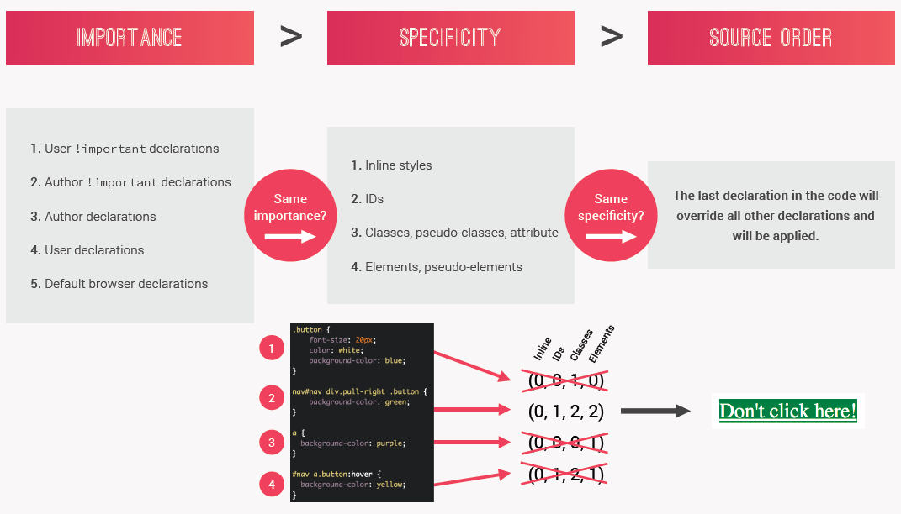

* Most common scenario is when we have a bunch of conflicting rules in our **author** stylesheets without any important keyword. All the declarations have the exact same importance.
* Now what happens in this case?
* Priorities/Categories – **Inline** styles have the highest specificity followed by **IDs**, then **classes**, **pseudo classes and attribute** selectors, and finally the least specific is the **element** and **pseudo element** selector.
* So when we have conflicting declarations with the same importance we calculate their selector specificity based on above priorities.
* The **specificity** is actually not just one number, but one number for each of the above four categories

Inline styles, IDs, classes, pseudo elements and attributes, and finally elements and for each of these we count the number of occurrences in the selector.

* Selector with maximum specificity wins and that style is applied. The value of the winning declaration is called the **cascaded value**, because it's the result from the cascade.
* E.g. As highlighted in black box above,

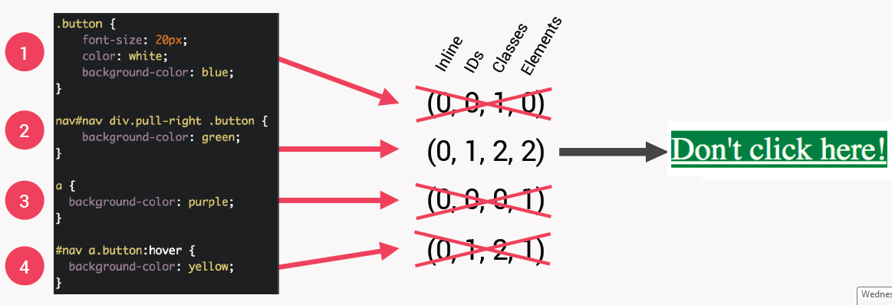

* + All these declarations have the same importance, because they're all author declarations without any important keyword.
  + For Selector 1 (highlighted in red circle), the specificity is (0, 0, 1, 0).  
    (0=> no inline style, 0 => no ID style, 1 => 1 button class style, 0 => no element style).
  + For Selector 2 (highlighted in red circle), the specificity is **(0, 1, 2, 2).**  
    (0=> no inline, 1=> 1 ID for #nav, 2=> 1 pull-right and 1 button class, 2=> 1 nav and 1 div element)
  + For Selector 3 (highlighted in red circle), the specificity is (0, 0, 0, 1).  
    (0=> no inline, 0=> no ID, 0=> no class, 1=> 1 anchor element)
  + For Selector 4 (highlighted in red circle), the specificity is (0, 1, 2, 1).  
    (0=> no inline, 1=> ID for #nav, 2=> 1 button class & 1 hover pseudo-class, 1=> 1 anchor el.)

#### Source Order

* We know that the Selector with maximum specificity wins and that style is applied. But what if more than one selector have same maximum specificity? (e.g. If we consider above example, image if 2 selectors have same max specificity as (0, 1, 2, 2).
* In this case, the last CSS declaration written in the code is applied.
* If everything is equal, if all the declarations selectors have the same specificity, then  
  the last declaration in the code will override all other declarations and will be applied.

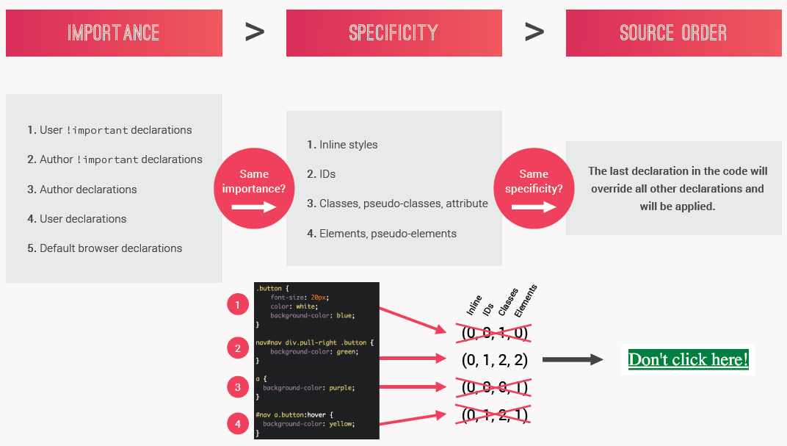

#### Summary

* CSS declarations marked with !important have the highest priority;
* But, only use !important as a last resource. It’s better to use correct specificities — more maintainable code! If something doesn't work the way you think it should then look at your selector specificities and figure out what's going on. That's always better than just adding important, which may solve the problem in an easier way, but will cause you problems in the long run.
* Inline styles will always have priority over styles in external stylesheets;   
  Writing inline styles isn't a good practice.
* A selector that contains even 1 ID is more specific than one with 1000 classes.  
  If you want to be really specific use an ID.
* A selector that contains even 1 class is more specific than one with 1000 elements.
* By default, browsers apply a certain margin, and/or a certain padding, to some elements. And we don't want that, obviously for consistency. Hence we must declare Universal selector in our CSS (* means Universal Selector). Along with real elements, we should also declare selector for all after and before pseudo-elements so that the declaration block will apply to all elements and we won’t have any inconsistent behaviour.  
  e.g. *,

*::after,

*::before {

margin: 0;

padding: 0;

box-sizing: inherit;

}

* The universal selector * has no specificity value (0, 0, 0, 0) which means that all other selectors have a precedence over it.
* Rely more on specificity than on the order of selectors. This way if you someday rearrange all your CSS code you won't have any surprises which could mess up your entire code. And this makes your code a lot easier to maintain.
* Rely on order when using 3rd-party stylesheets — **always put your author stylesheet last**.

## How CSS is Parsed: Part 2 (Value Processing)

* Why is it important to know this?
* Two reasons –
  + Each time you use a unit other than pixels, like rem or vh or some other relative unit, it will ultimately be converted to pixels.
  + Also knowing this stuff, will is predict and control better which property takes which value in the end.

### How CSS Values Are Processed

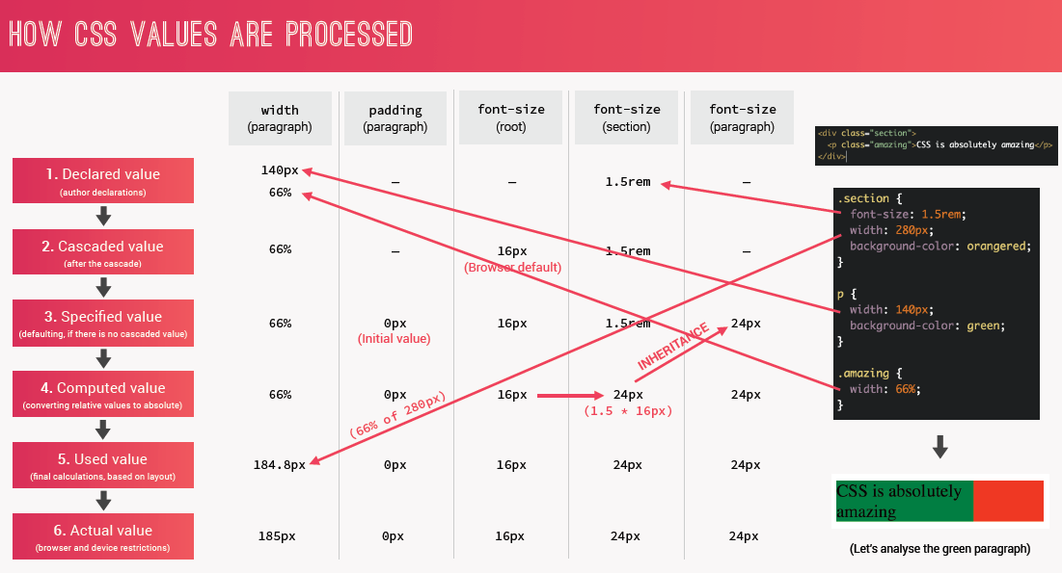

* Let’s analyze the width, padding, and font-size as declared in above example.
* Cascaded Value – value calculated in the first step of Parsing CSS – Resolving Conflicts.
* Specified Value – the default value of a certain CSS property. (This is used if we don’t have any cascaded value already. Otherwise not used.)
* Computed Value –
  + In this step, values with relative units are converted to pixels so that they can be inherited.
  + CSS key words like “orange”, “oral”, “boulder” and a lot more are computed and replaced here in this step.
* Used Value – In this calculation step, the CSS engine uses the rendered layout to figure out some of the remaining values, for example percentage values that depend on the layout.
* Actual Value – browsers usually cannot really display decimal pixels e.g. 184.8 pixels. That's just way too specific and so usually, such is simply rounded. This is the final value which is used in the layout for rendering by considering the browser and device restrictions.
* Each and every CSS property needs to have a value even if we don't even declare it at all. That is where the “Specified Value” comes into picture. Each CSS property has something called an "initial value" which is simply the value used if there is no cascaded value.
* So basically, if we don't declare a value and if neither the browser nor the user define a value, then the initial value will be used. Actually, inheritance also plays a role here.
* Different properties have different initial values of course, and for padding, it's zero pixels, which is obvious.
* Root font-size means the overall font-size of a document.
* Browsers has default value of a root font-size for each page (usually 16px). But we can also set it in our HTML selector.
* Some properties like the ones related to text, such as font-size, inherit the computed value of their parent elements.

### How Units Are Converted From Relative to Absolute (px)

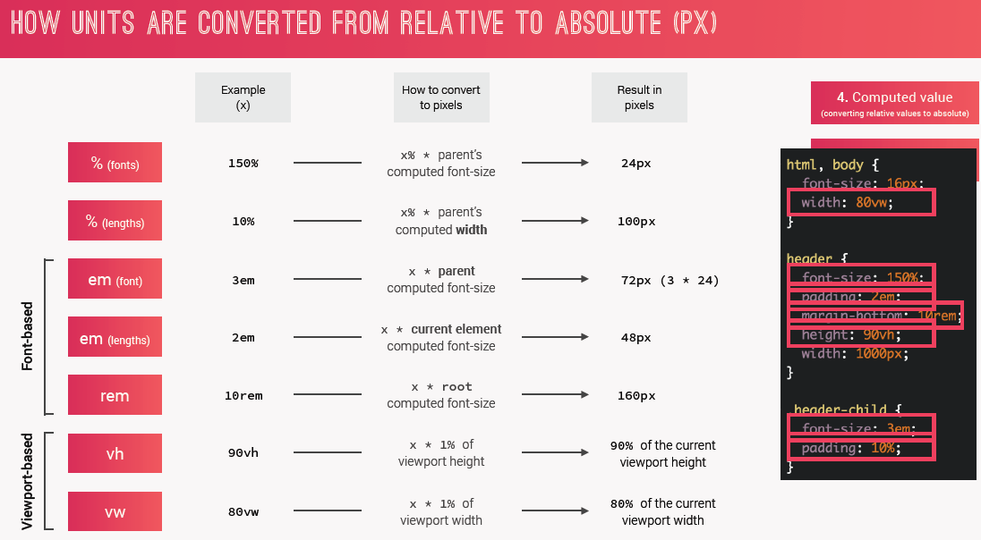

* It is important to know how the CSS engine converts relative units to pixels in order to calculate **Computed** and **Used** values. Because this is crucial to know when we write our own code so this has actually a very practical application in the real world and relative units are fundamental to build modern responsive layouts.
* There's a distinction between using percentages for fonts and for length/distance measurements.
* Percentages are measured relative to their parent’s **font-size, if used to specify font-size**.
* Percentages are measured relative to their parent’s **width, if used to specify lengths** (e.g. like height, padding, margin, etc.).
* Both **em** and **rem** are **font-based**, but the difference between them is that **em** use the parent or the current element as a reference while **rem** use the root font-size as the reference.
* If **em** is used for **font-sizes**, then the reference is simply the **parent's** computed font-size (similar to what happens with percentages).
* If **em** is used to specify **lengths,** then they are measured **relative to the** **current** font-size.
* **rem** unit is always relative to the root font-size.
* For **both font-sizes and lengths**, if **rem** unit is used, it is always relative to the **root font-size.**
* Why should we actually size (length) stuff with em and rem if they are based on font-size?
  + by doing so, we can build more robust responsive layouts because just by changing font sizes, we will automatically change length since it depend on a font size and that gives us a lot of flexibility, and it's just a great technique.
* 1**vh** is just 1% of the browser’s view port height.
* 1**vw** is just 1% of the browser’s view port width.
* **vh** is really useful to build nice hero sections for a webpage.

### Summary

* Each property has an initial value, used if nothing is declared (and if there is no inheritance — see next lecture)
* Browsers specify a root font-size for each page (usually 16px)
* Percentages and relative values are always converted to pixels in order for the CSS engine to be able to render the page on the screen.
* Percentages are measured relative to their parent’s font-size, if used to specify font-size.
* Percentages are measured relative to their parent’s width, if used to specify lengths.
* **em** are measured relative to their parent font-size, if used to specify font-size.
* **em** are measured relative to the current font-size, if used to specify lengths.
* **rem** are always measured relative to the document’s root font-size.
* **vh** and **vw** are simply percentage measurements of the viewport’s height and width.

## How CSS is Parsed: Part 3 (Inheritance)

Inheritance is a way of propagating property values from parent elements to their children.

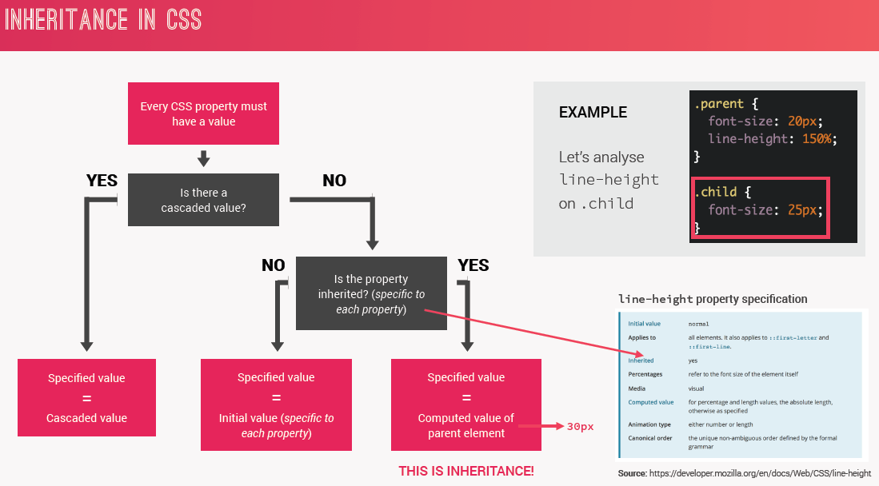

### Summary

* Inheritance passes the values for some specific properties from parents to children — Inheritance allows the developers to write less code and code that will be more maintainable.
* Properties related to text are inherited: font-family, font-size, color, etc;
* Other properties like margins or paddings are, of course, not inherited.
* The computed value of a property is what gets inherited, not the declared value.
* Inheritance of a property only works if no one declares a value for that property;
* We can use the inherit keyword to force inheritance on a certain property;
* The initial keyword can be used to reset a property to its initial value.

## Converting px to rem

* We should use rem instead of px.
* Why?
  + That’s because we want an easy way to change all the measurements on our page with one simple setting.
  + For instance, when we hit a break point to display our page on a mobile device, we want a way to decrease all the measurements in our site at the same time, and instead of writing hundreds of lines of code and in media queries, we can just change one global setting, and that is the global font size.
  + We know that rem unit is always in relation to the root font size. Now if we now set that root font size, we can and very easily change all the other measurements on our page to rem. The root font size is set in the HTML selector.
* When we are doing responsive design and modern design, and modern CSS development, then it's really good practice to use relative units like rem.
* Using em is a whole lot of work because as we know em depends on its parent’s font-size so we have to do a lot of calculations and it becomes really, really difficult to manage.
* Note: rems are not supported below Internet Explorer 9.
* Root font size should be set/evaluate to 10px.
  + Why 10, bcz 1 rem = root font-size. So here 1 rem = 10px. So now it's easier for us to do calculations (w.r.t 10) while assigning rem based font-sizes/length units.
  + If it were say 16px, then we would have to do lot more calculations in each selector which takes away lot of our time.
* We should **NOT** set Root font-size in **px** but should be set in **percentage**.
  + The problem is that by doing so we actually override the browser font size setting that the user can manually change in the browser settings and many people actually do that. e.g. when they have bad sight and cannot see so good, then some people actually increase the default font size of their browser.
  + So if we set our ROOT font-size in px, then we remove the ability for these people to see our website properly because they can no longer change the default font size (they can, but our root font size will not be affected by that anymore).
  + So this is a really bad practice, and that is why we should set overall font size to a percentage, which will translate to a percentage of the font size given by the browser.
* Let’s take an example –
  + Now the default font size, if the user doesn't change anything is 16 pixels.   
    But we want root font-size to be 10px for our ease (why? As mentioned in one of above points – for easier calculations and assignment on rem based font-sizes/length units.
  + So Default browser font-size is 16px.
    - But we want root font-size to be 10 px, then 10/16 = 0.625 => 62.5%   
      So by default 62.5% translates to 10px (0.625 * 16).
    - If user changes to 20px, then 62.5% translates to = 12.5px (0.625 * 20).
    - If user changes to 22px, then 62.5% translates to 13.75px (0.625 * 22).
  + So with this we allow the user to actually zoom in on the page automatically, not only to change the font size, but to also to zoom in on the page, because basically what happens is Not exactly zooming, but increasing all of the measurements that we have on our page.
  + This is really widely used technique in the CSS developer community because it's so simple and yet so powerful.
* Whenever we can use inheritance, we should use it instead of using something like the universal selector (*).
* box-sizing property by itself is not inherited, but by setting the box-sizing property on universal selector (basically each and every element on the entire page) to inherit, it'll automatically inherit whatever we set the border-box property in **body** selector. So this is considered a slightly better practice by the CSS community because it makes it a bit easier to change the box-sizing like in plugins or other components where we might want to use a different property for box-sizing. It doesn't make a huge difference, just a slightly better practice to do the box-sizing border-box like this.

## How CSS renders a Website? (The Visual Formatting Model)

(Refer Flow: What Happens To CSS When We Load Up A Webpage?)

* The Visual Formatting Model – It’s an Algorithm that calculates boxes and determines the layout of theses boxes, for each element in the render tree, in order to determine the final layout of the page.
* This model is one of the fundamental concepts of CSS.
* In order to do this, the algorithm takes into account factors like
  + dimensions of the boxes, which are calculated by the box model.
  + The box type, which can be inline, block or inline-block.
  + The positioning scheme which includes concepts like floats and absolute or relative positioning.
  + Stacking context
  + The other elements that are present in the render tree such as siblings or parents.
  + external information such as the current viewpoint size, dimensions of images, or other factors.
* By putting all these factors together, the browser figures out how the final website will look for the user.
* Let’s look into those one by one.

### The Box Model

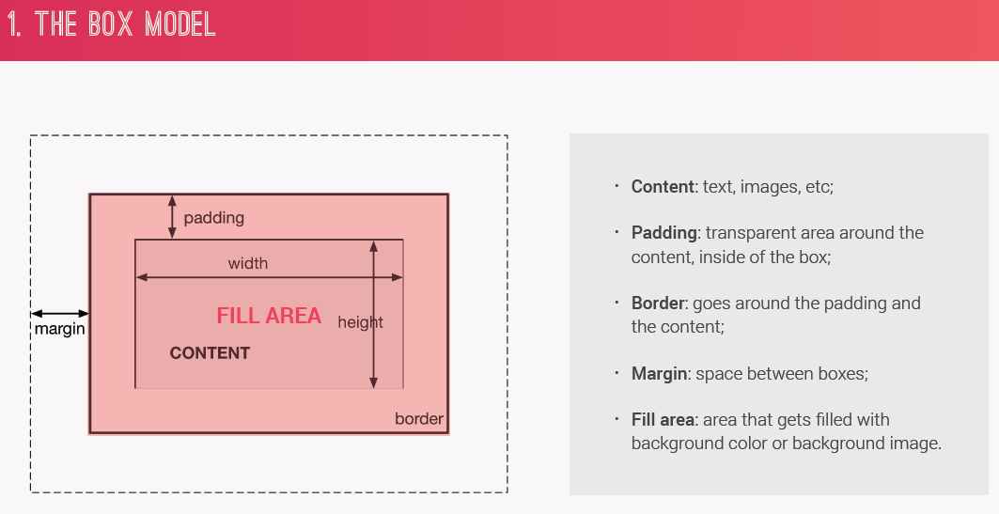

#### Box Model: total Height & Width (box-sizing: content-box)

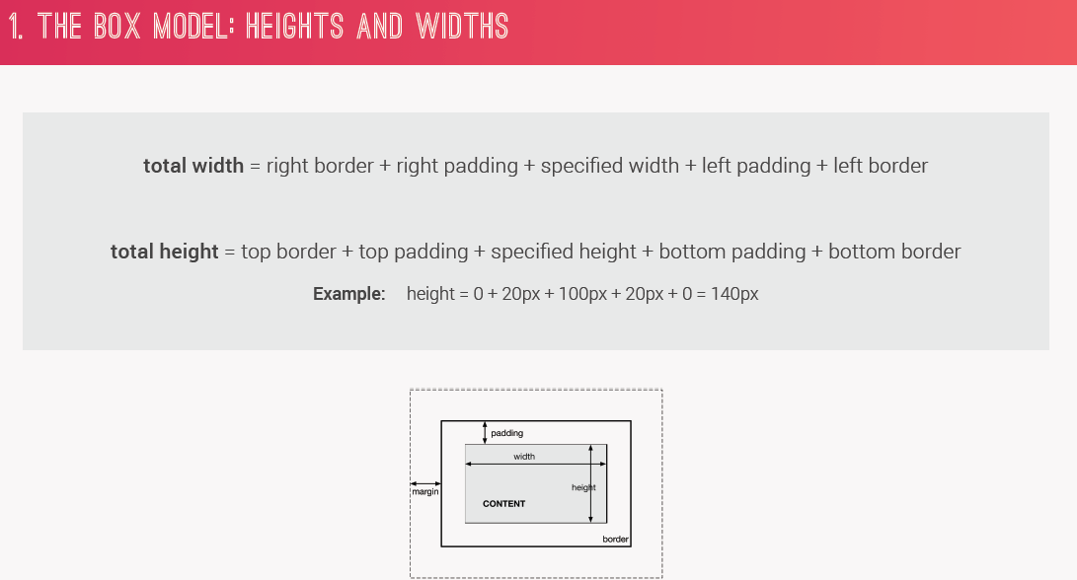

#### Box Model with box-sizing: border-box

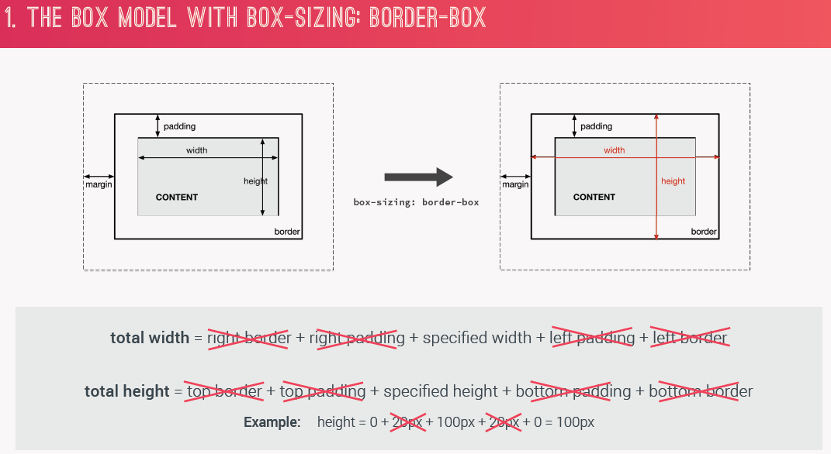

### Box Types: inline, block and inline-block

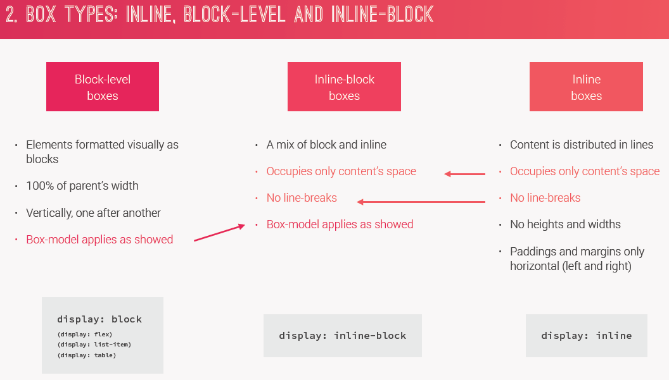

### Positioning Schemes: normal flow (default and relative), absolute positioning (absolute and fixed) and floats (float: left, float: right)

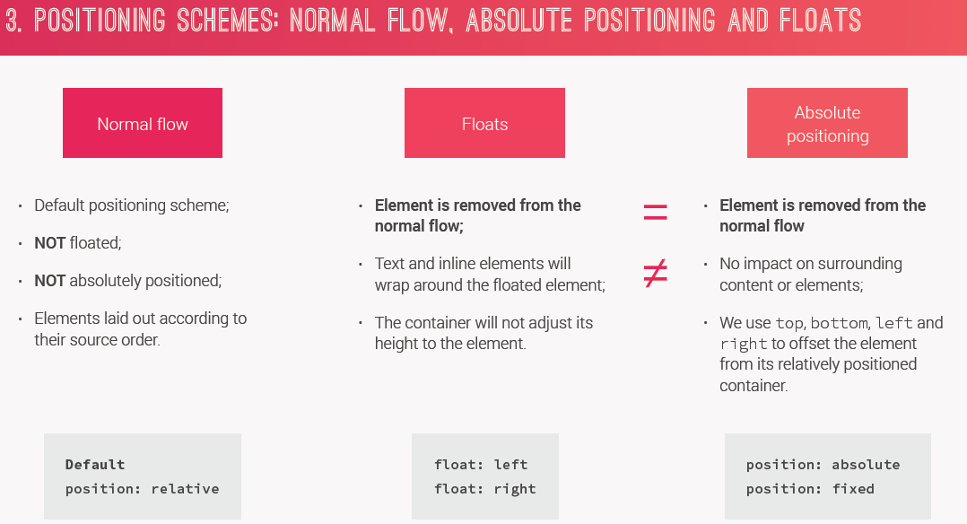

* Floats –
  + The float property causes an element to be completely taken out of the normal flow and shifted to the left or right as far as possible, until it touches the edge of its containing box, or another floated element.
  + When this happens, text and inline elements will wrap around the floated element.
  + Also, when an element is floated, its container will not adjust its height to the element, which sometimes can be problematic. The usual solution to this is to use clear fixes.
* Since an absolutely positioned element has no impact on surrounding content or elements, it can overlap other elements occupying the same space. But CSS solves it for us using something called stacking context.

### Stacking Contexts

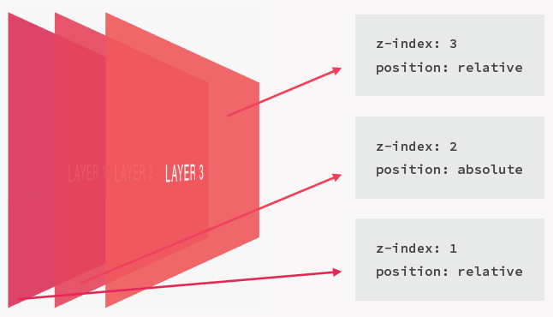

* Stacking contexts determine in which order elements are rendered on the page.
* A new stacking context can be created by a different CSS properties, where the most widely known is z-index. But there are other properties that also create new stacking contexts.
* Stacking contexts are like layers that form a stack. Layers on the bottom of the stack appear at first, and elements higher up the stack appear on top, overlapping the elements below them.
* Between these elements, the one with the higher z index appears on the top, and the one with the lowest z index appears at the bottom.
* Properties which can create stacking context are z-index, opacity, transform, filter, etc.

## CSS Architecture, Components and BEM

* This is about CSS architecture, how we should think about layouts, and how we should mark up our code in a professional way.
* Remember that we want code that is clean, modular, reusable, that makes it easy to add more and more features to our webpage or app if it needs to grow.
* Because of all of these reasons, we cannot just dive into a new project and leave architecture behind just as a second thought.
* We need to take important decisions concerning our HTML and CSS code right from the beginning of the project.
* We need a good strategy – a good mindset.

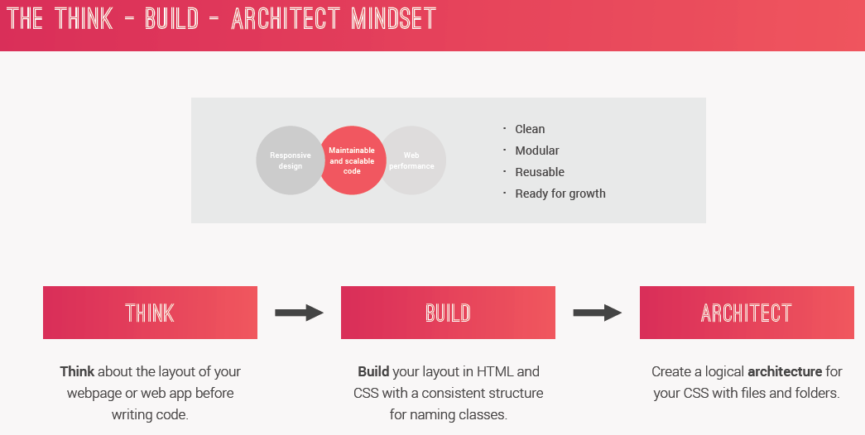

### Think

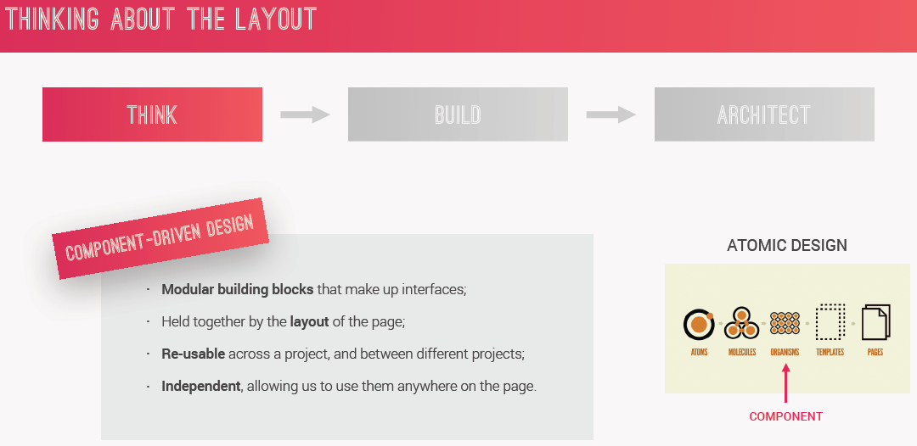

* With component-driven design, we try to divide our page into modular components.
* Components are the building blocks that we use to construct our interfaces.
* So we can basically think of our interface as a collection of components held together by the overall layout of the page.
* Components should be reusable across a project and also between different projects.

So you can build a library of your components and then reuse them across projects, which will speed up your development.

* Components should be independent so that we can use them completely on their own no matter where on the page. What this means is that components should not depend on their parent elements.
* All of this will make your CSS code easier to maintain and to scale if necessary.
* According to atomic design, the smallest units on a page are atoms, which together form molecules, which combine together to form organisms. And these organisms can be seen as our components in some situations.

### Build

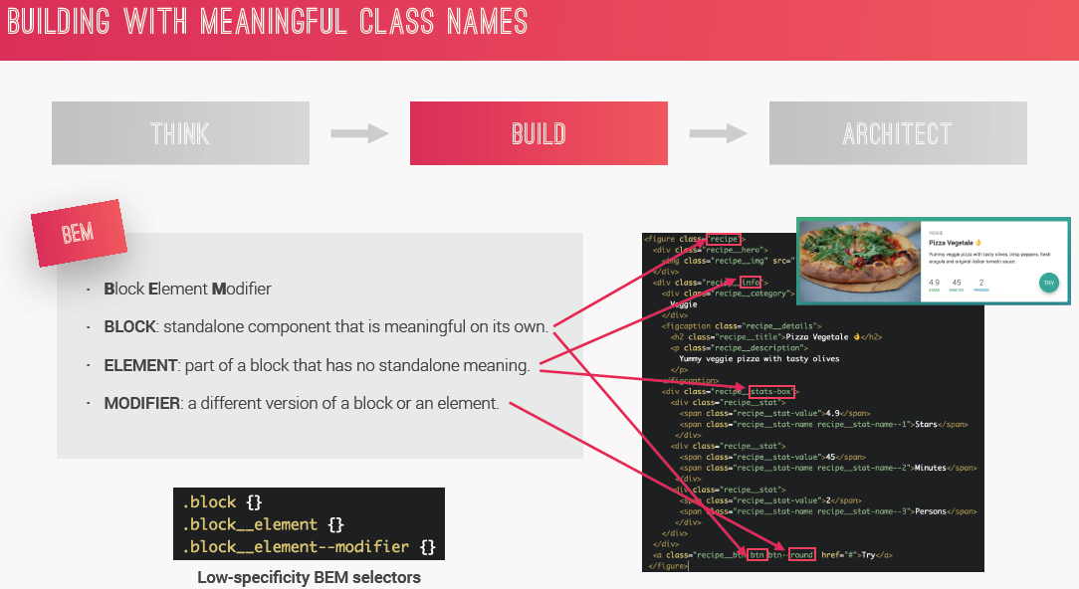

* After thinking about the design, we need to code the design using HTML and CSS, and in this step, it's important to have a consistent strategy and structure for naming our classes.
* Approaches for naming our classes – Object-oriented CSS or S Max, BEM.
* BEM, which is becoming more and more popular by developers around the world.

#### BEM (Block Element Modifier)

* It's a nice clean system for marking up our layouts.
* In BEM, a **Block** is a standalone component that is meaningful on its own, and can be reused anywhere in the project.
* We can have nested blocks and that is perfectly normal and acceptable.
* An **Element** is a part of a block and has **no meaning on its own.** i.e. if we take one of these elements out of the block then they wouldn't be useful at all.
* The **Modifier** is a flag that we can put on a block or an element in order to make it different from the regular blocks or elements. To make a different version, let's say.
  + For instance, there may be some rules for all buttons, and then we use a modifier to make a more specific, different button. E.g. big button, small button, etc.
* BEM creates selectors with really low specificities because we always use classes and they are never nested. And so they always have a pretty low specificity, and this is one of the big reasons why BEM is so widely used for easy to maintain and reusable code.
* If we follow BEM, then just by reading the markup with those class name, we can instantly see how all elements are related and what each of them does.

### Architect

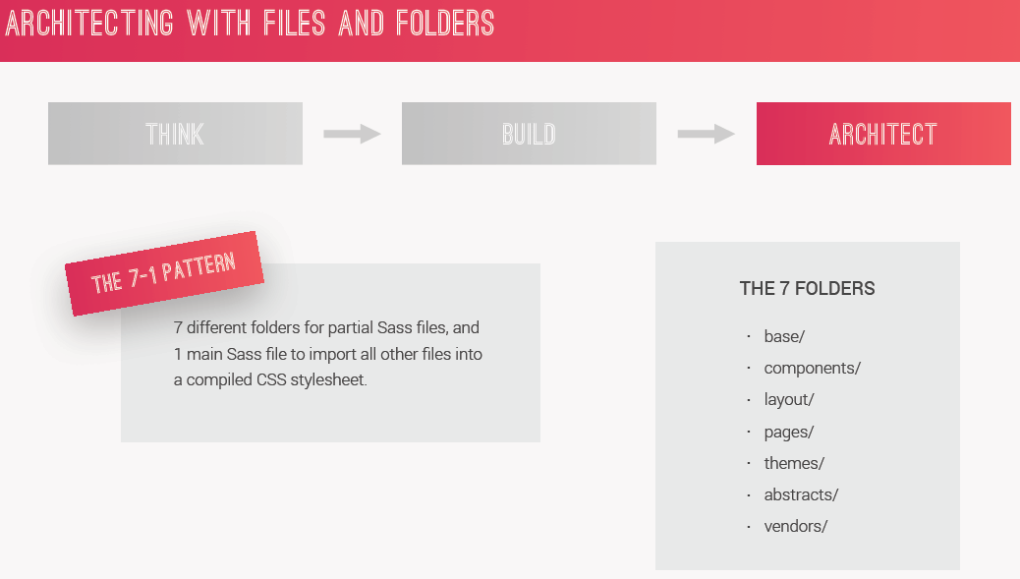

* Architecting CSS means to create a logical folder and file structure for our CSS to live in.
* There are different options like the ITCSS method or S Max, the 7-1 Pattern.

#### The 7-1 Pattern

* The 7-1 Pattern is extremely simple. All it means is that we have seven different folders where we put partial Sass (or any other CSS Preprocessor) files, and then one main Sass file in which we import all of our partial files into one final compiled CSS stylesheet.
* The 7 folders are –
  + **base** folder where we put the basic product definitions.
  + **components** folder where we have one file for each component. Components are our building blocks which are independent and reusable everywhere across our website.
  + **layout** folder where we define the overall layout of the project e.g. global footer, header, etc. and holds all of the components together.
  + **pages** folder where we have styles for specific pages of the project.
  + **themes** folder if you want to implement different visual themes.
  + **abstracts** folder where we put code that doesn't output any CSS, such as variables or mix-ins
  + **vendors** folder where put all third party CSS.
* We don't always need to use all of these folders. It's gonna depend on the size and the scope of the project.

# Introduction to Saas and NPM

## What is Saas?

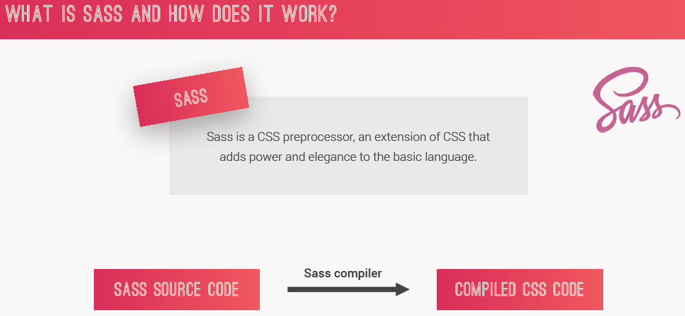

* **Sass** is a CSS preprocessor, an extension of CSS that adds a lot of power and elegance to the basic language.
* So basically, we use Sass to fix the problems that we have with CSS.
* CSS gets very messy, very quickly.
* For each project, having a single CSS file with thousands of lines of code without any reusable pieces, without any logic, gets completely unmanageable after some time.
* That's why we use Sass which provide us with a couple of handy features and tools that CSS simply doesn't have, while at the same time, not changing the fundamental way that CSS works.
* The way Sass works is like this –
  + Instead of writing a CSS file with regular CSS code, we write Sass code in Sass files.
  + Then, we run a compiler, and that compiler converts the Sass code we wrote into regular CSS code as if all we ever did was write in regular CSS in the first place.
* So, we need to process our Sass code first, and that's why it's called a CSS preprocessor.
* Our website has no idea that the code we wrote in the beginning was in Sass because it only ever sees the final output of the compiler in the form of CSS.
* There are actually other CSS preprocessors like **Less** or **Stylus**, but **Sass** is the most popular one.

### Features of Saas –

* **Variables** – which allow us to have reusable values such as colors, font sizes, spacing, etc.
* **Nesting** – in order to nest selectors inside of one another, allowing us to write less code.
* **Operators** – for mathematical operations right inside of CSS.
* **Partials and Imports** – which are one of the most important and most useful features of Sass, allowing us to write CSS in different files, and then importing them all into one single file.
* **Mixins** – to write reusable pieces of CSS code. The code is copied as it is where it is used.
* **Functions** – which are quite similar to mixins with the difference that they produce a value that can be used later.
* **Extends** –
  + **Extends** can be used to make different selectors inherit declarations that are common to all of them.
  + We should **only** ever use extends if the rules that we're extending are inherently and thematically **related**. E.g. buttons of different types, etc. Otherwise it may cause maintenance problem.
  + Use extends when the selectors or the elements that you are extending are actually pretty related to one another.
  + CSS code written inside Extends is not copied to each and every element where is it used (but the selectors where is it used themselves get copied in place of Extends declaration).
  + There is this subtle difference between Mixins and Extends. (Use codepen to see the difference in final compiled CSS.)
* **Control directives** – allow developers to write complex code using conditionals and loops like in real programming language. It's nearly not needed in a real world project. It's more for writing CSS frameworks or something.
* SASS comes in with a couple of built-in color function which can make life our life easier. Instead of having to calculate another color, we can simply use one of the built-in color functions. E.g. darken(), lighten(), etc.
* The function, mixin are just like the variables, they will not produce any final CSS code, because their only purpose is to help us writing our code.
* Basic introduction to how to use variables, functions, mixins, extends –
  + Sass Introduction: Variables, Nesting:   
    <https://codepen.io/sameer-bhilare/pen/ExKKYLP>
  + Sass Introduction: Mixins, Functions, Extends:   
    <https://codepen.io/sameer-bhilare/pen/NWNNPKr>
* A valid CSS is also a valid SCSS as the syntax is quite same.

### Sass syntaxes

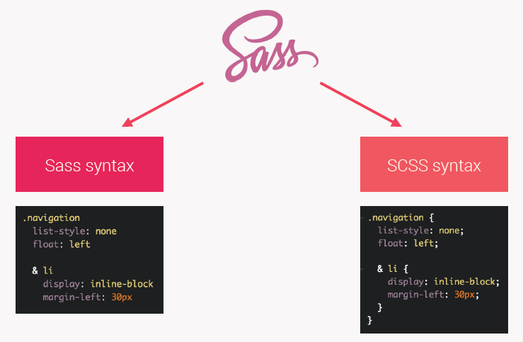

* There are two Sass syntaxes as you can see above.
* One syntax, which is actually the original one, is just called Sass.
  + The Sass syntax is indentation sensitive and doesn't use any curly braces and semicolons.
  + this syntax a bit confusing, and more difficult to learn, and also more difficult to convert original CSS projects.
* The other one is called SCSS which stands for Sassy CSS. And the SCSS syntax preserves the way that original CSS looks like. (More preferred way)
* Whichever syntax you choose, it will work the same way in the end.

## NPM

* NMP package ecosystem is where we can find all kinds of open source tools and libraries and frame works needed for modern web development.
* Node JS is an open source JavaScript run time that allows developers to write and run JavaScript application on the server.
* Developers started using Node to also write tools like for test automations, or to compile SASS to help them with local web development.
* In order to use and share these packages we need some kind of tool to install and to manage them.

That is where the NPM comes in.

* NPM is a simple command line interface that allows developers to install and manage packages on their local computers. Plus NMP also allows us to do some automations of boring tasks.
* There are all kinds of open source tools, libraries and frameworks needed for modern development.
* Modern web development could simply not exist without a package manager.

### Installing Saas

* Before installing our first package, usually the first thing that we always do in a new project is to create a package.json file which basically will contain the definitions of our project and where NMP will write the packages that we use.
* To create package.json,
  + npm init
* Now let’s install Sass
  + npm install node-sass --save-dev
  + --save-dev because we want this to be dev dependency only as it is just development tool and will not be part of final deployable. And this will install the package **locally**, that is only for that project in which is it installed.
* The important reason we should use --save-dev or --save option in the package.json file is that by this way we can then share our project without sharing the entire node_modules folder. And so if someone else receives our project, they can just do npm install and then all of the dependencies will be automatically installed.
* Why do we have to worry about writing dependencies and dev dependencies in package.json?
  + That’s because we can then share the project along with package.json file and without the node_modules folder to others and others can exactly recreate the project with exactly same dependencies and version on their local by just running npm install command.
  + npm install will take a look at our package.json file and download exactly the packages that we specified there.
  + So this package.json file is really useful in each project where we have NMP modules.
* To uninstall a package from our project, use npm uninstall <package-name> -- save
  + E.g. say we want to uninstall jquery from a project  
    npm uninstall jquery --save  
    This will uninstall jquery and because of the --save flag will the dependency will be removed from package.json file.

### Running Sass package

* Since we have installed node-sass, in order to actually run it against our project, we need to write an NPM script for that.
* We need to write that script in the package.json under key “scripts”.
* E.g.

"scripts": {

    "compile:sass": "node-sass sass/main.scss css/style.css"

 }

* And you can now run this script like this –   
  npm run compile:sass
* This will compile your sass input file from given source folder and will create css file at given destination folder.
* This is only one of the many possible scripts that we could write in the package.json.
* There's so many packages on NPM. There are packages to automatically prefix our code in order to support all of the web browsers. There are packages to compress our code, and so much more.
* Now every time we make changes to sass file, we need to compile it to css file. That is not really practical. But luckily we have a solution for this. The node-sass package allows us to to keep watching our main "sass" file by just adding –w option to our node-sass command.

"scripts": {

    "compile:sass": "node-sass sass/main.scss css/style.css –w"

}

* Once you make this change, run the command again and then start making changes in your sass file, it will automatically create css file from it and your changes will be automatically reflected.  
  npm run compile:sass
* So now each time that we write some more SASS code, it automatically compiles and we can then check out our page directly. The only thing that you have to keep in mind is that the the npm run command above should be running in some command window or terminal.

### Automatically Reload your Project on any file changes

* We just need to install an npm package that automatically reloads on a complete project as soon as we change any file in the project folder.
* The npm package to do this is **live-server**.
* We want to install this package globally, because we want to be able to use it, not only in a particular project, but also on all future projects and anywhere on our computer.
* So the command to do so is   
  npm install live-server -g
* -g means globally. And you will see that this package will neither be in the dependencies of package.json nor in node_modules folder. That’s because we installed this one as a global package.
* Since it's a global package, we can actually call it directly from the command line. And we don’t need to write any script in the package.json file.
* Command to the this live-server package –   
  live-server
* Once you run this command, you will see your webpage will open in your browser at <http://127.0.0.1:8080/> (BTW we can change the port number in configuration.)
* Now all we need to do was to change the code and come back to the browser and everything updated for us very nicely and we didn't have to click the reload button.

# Three main ingredients to responsive web design.

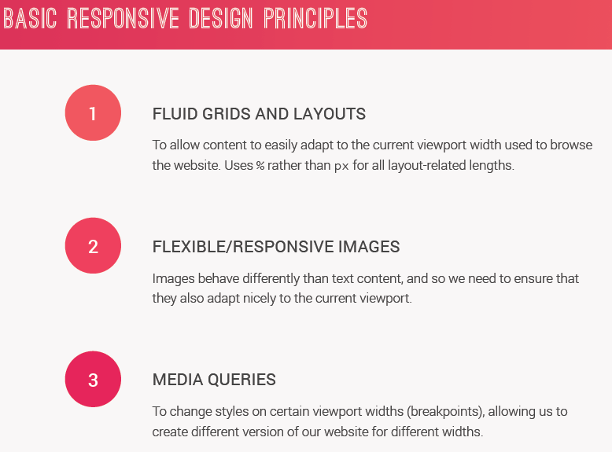

1. Fluid Grid –   
   In a fluid grid all layout elements are sized in relative units like percentages instead of absolute units like pixels.
2. Flexible Images –   
   Are also sized in relative units.
3. Media Queries –

Allow us to specify different CSS style rules for different browser widths.  
With media queries we can target different devices like mobile phones and tablets and make the website respond to their screen size.

## Layout Types

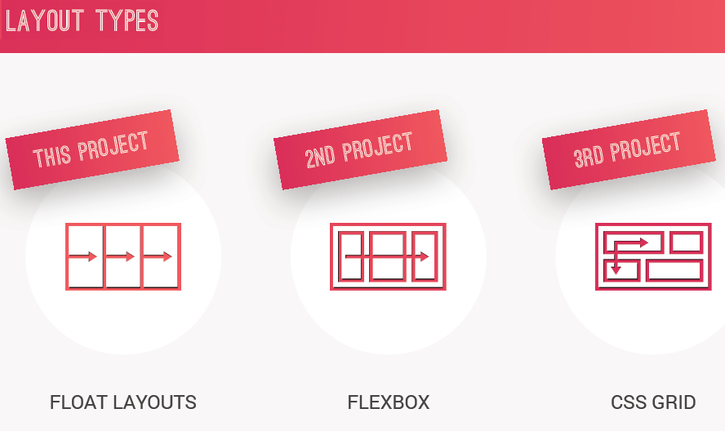

* In modern web design there are currently three major ways of laying out a webpage or app.
* Float Layouts –
  + We simply put a bunch of boxes side by side, using floats.
  + This method is still being used because the alternatives are still not 100% supported by all browsers.
* Flexbox –
  + Offers an amazing way of laying out elements in a one dimensional row.
* CSS Grid –
  + Perfect for creating the overall layout of a page in a fully-fledged 2D grid.
* The layout is the single most fundamental aspect of our design, and so if a browser does not support a technology like Flexbox or CSS grid, then that's a major problem and can ruin our entire designs.
* Moving forward in the future, we will always have to know how to use all of these three layout types.

# Advanced Responsive Design

* Two fundamental aspects of modern responsive design are –
  + Deciding about doing mobile-first or desktop-first for website or app and
  + Selecting breakpoints for our project, when writing media queries.

## Desktop-First Vs Mobile-First

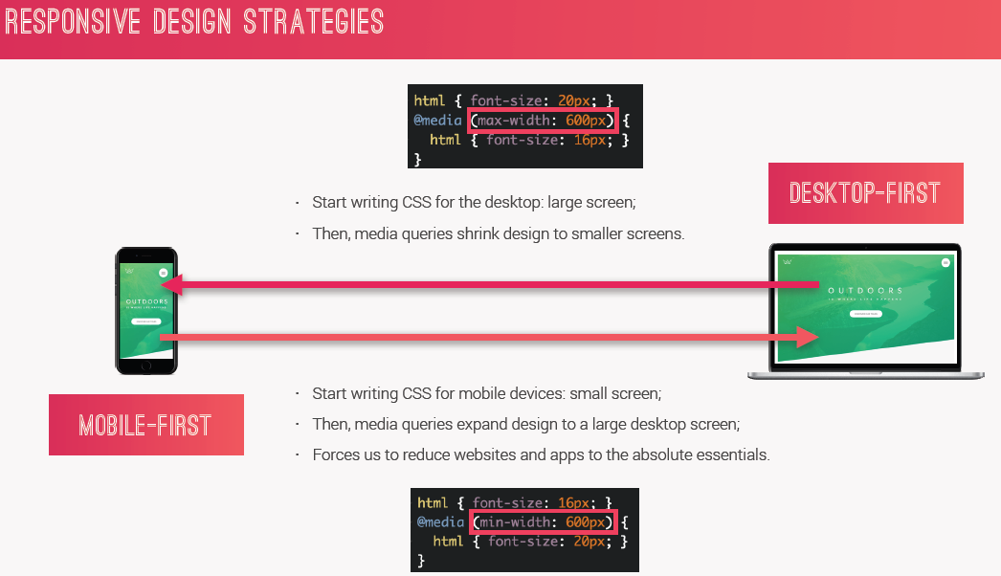

* **In the Desktop-First approach,** 
  + We optimize our interfaces for the large screens. And therefore, we start by writing CSS code for these large screens, into our CSS file.
  + Then later, when we make the website responsive, we simply write media queries, in order to shrink the design to fit the smaller screens (writing media queries that test for **max-width** -The maximum width till which the media query is applicable).
  + This is the more traditional way of doing things and also the easier way to learn.
* **In Mobile-First approach,**
  + We start writing CSS code for smaller screens, in order to optimize for mobile.
  + And then, move up to larger screens from there using media queries (writing media queries that test for **min-width** - The minimum width at which the media query starts to apply).
  + The main strategy behind Mobile-First is we really have to think about the mobile experience, by reducing our websites or apps to the absolute essentials. Stripping away everything that's not really necessary, in order to end up with a smaller and faster final product.
  + We have to use min-width type of media query in the mobile-first approach, because basically we want the queries to stay away from our smallest screen styles. So, we want them to work for bigger screens, and so the max-width approach wouldn't work.

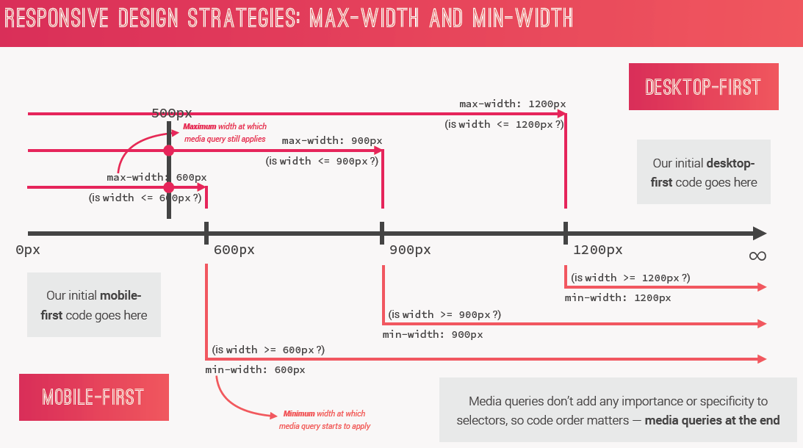

* Think of media queries as tools, to overriding specific parts of our CSS for specific viewport width.
* If you have conflicting CSS rules in media queries, which is usually the case, like defining the global font size in both media queries, then the one which appears last in the code is the one that takes precedence. That's because media queries don't add any importance or specificity to our selectors. And so, the order of the code matters a lot. And, that's why we **keep our media queries always at the end.**

## What’s best for us?

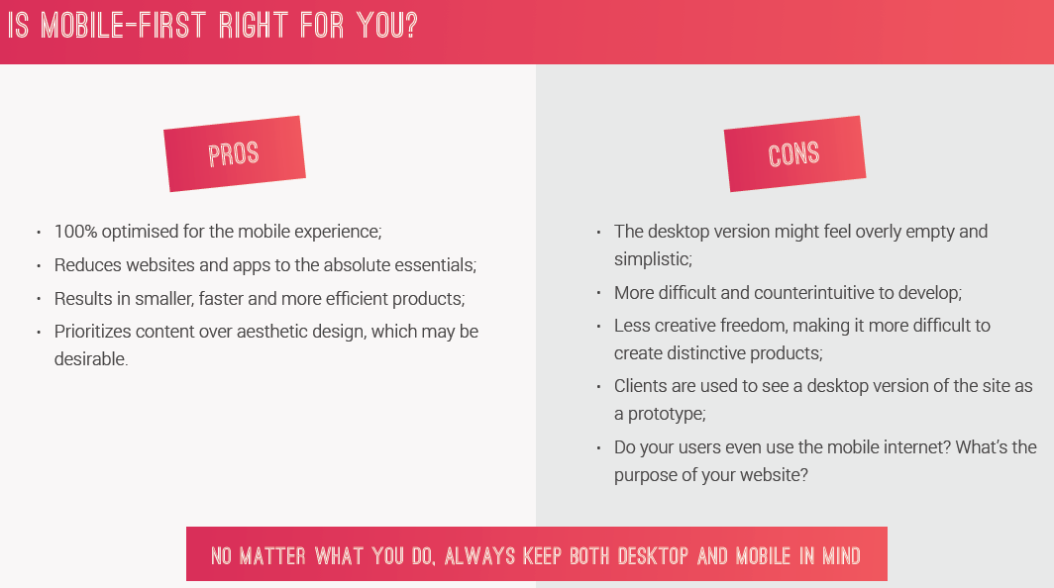

* No matter what you decide, always keep both the desktop and mobile versions in mind and understand that they are both important. You should never design only for one of the solutions and just leave the other one as an afterthought.

## Selecting Our Breakpoints

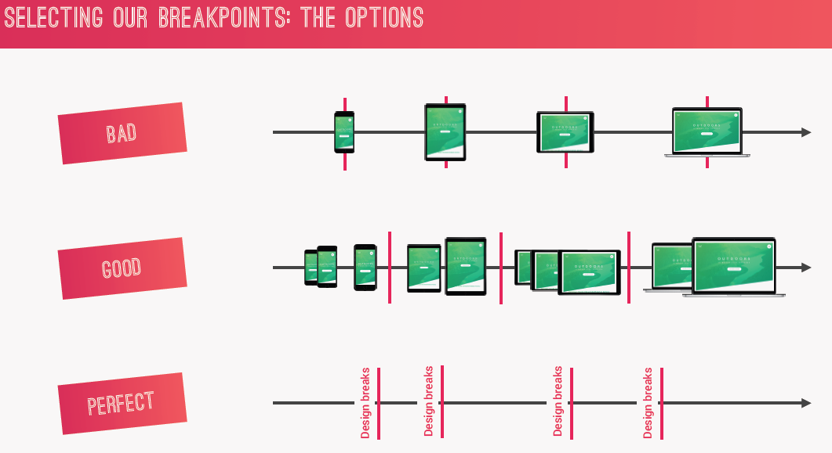

* Breakpoints are the viewport width at which we want our design to change.   
  In other words, where we want to put our media queries.
* Usually, we'll need one breakpoint for phones, one for portrait tablets, one for landscape tablets and one for the desktop. There can be more, of course, but these are the basics.
  + The phone ranging from 0-600 pixels,
  + portrait tablets from 600-900
  + The landscape tablet from 900-1200
  + Desktops from 1200+
  + Big desktops starting at 1800 pixels.
* There are three major ways of selecting breakpoints – Bad, Good and Perfect.

### Bad Way

* Unfortunately, the bad way is also the most used way of choosing breakpoints.
* It consists of simply using the width of popular devices as the breakpoints like the iPhone and the iPad, to set breakpoints for their screen width.
* While this is the easiest way, it has a couple of **problems**.
  + First, you're optimizing for one very specific device, ignoring all the users of other devices, which may be even more used than the Apple products.
  + And, second and even more important is that this strategy is not future proof at all.   
    E.g. If tomorrow Apple decides to completely change resolutions on all their devices, we would need to change all of our media queries.
  + So using specific devices as breakpoints is completely against the logic of reusable and maintainable code.

### Good Way

* In the good way, we look at all the most-used device width on the entire internet, try to group them together in a logical way and then pick our breakpoints from that.
* It's a lot better than the first way because we're using a lot of devices, and we're also using the most popular device width. Plus, we're not setting breakpoints at one specific point but between similar device widths.

### Perfect Way

* The perfect way to do this is to ignore devices all together and only look at your content and your design.
* Ideally, it works like this – You begin at one size, either mobile or desktop and then start increasing your screen width or decreasing for desktop first. Then, as soon as the design breaks, which means that the design no longer works or it no longer looks okay, then you insert a new breakpoint.
* So you just put the breakpoints wherever your design starts to look weird and out of place, and don't think about devices, at all.
* This approach can be extremely difficult. And, that's why not many people are doing it.
* Without the constraints of at least a couple of pre-defined breakpoints, it's hard to find the best ones and not to end up with really a bunch of them.

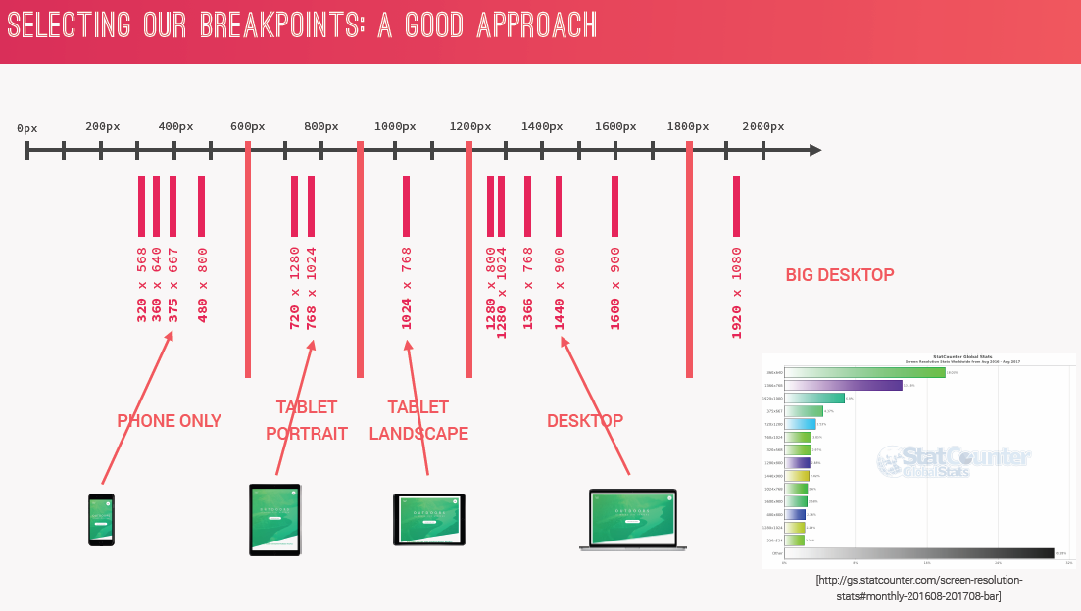

## Writing Media Queries

* We should not use pixels in the media queries. That's because if the user changes the default font size in the browser, then the media queries would not be affected by that. And we won't get desired results.
* Important note about rems and ems in media queries –
  + ems and rems in media queries are NOT affected by a root font size setting.
  + What that means is that 1rem or 1em in a media query is always equal to the font size which is coming from the browser.
  + And that's by default 16 pixels, but if the user changes it to 20 pixels, then it will be 20 pixels no matter what we have in our base/root font definition.
* We should use ems instead of rems in media queries, because rems fail to work as intended in some of the browsers. There's been some experiments done by people who understand a lot of all of this, and the conclusion basically is that **ems are the BEST option for media queries**.
* So the ems will be converted to pixels and will be adopted to the font size that the user set for the browser. So, it's a more accessible and dynamic solution here instead of using the pixels.
* While writing media queries, sequence does matter that’s because one media query can be applicable to more than one breakpoints e.g. in cases when we are only using max-width, and NOT both max-width and min-width while writing one media query.   
  @media (max-width: 800px) { … } // only using max-width  
  @media (min-width: 600px) and (max-width: 800px) { … } // both min & max
* Always write the larger (meant for bigger sizes) media queries before the smaller (meant for smaller screen sizes) ones.

# Tips & Tricks

* There are generally two types of animations in CSS.
* The first one, which is also the easier one, is to just use the transition property, and then change the properties that you want to animate on an event, like when we hover the element.
* Second one is advanced and cooler and actually a bit more advanced and cooler. Because these animations allow us to put more options and so they are a bit more complex but they allow us to put more options. (using keyframes)
* For the browser performance, it's best to only ever animate two different properties.

One is opacity, and the other one is the transform property. The browsers are optimized for these two properties. But with transform, we can do a whole lot.

* :link - pseudo class. pseudo-classes are a special state of a selector. We use pseudo-classes to style elements under a special condition. E.g. :link, :hover, :active, etc.
* pseudo-elements allow us to style certain parts of elements.  
   E.g. ::after pseudo-element adds like a virtual element right after the element that we're selecting. And we can then style that element in order for an after pseudo-element to actually appear on the page, we need to specify its content property. It doesn't matter what the content is. It can even be empty but we have to specify it. Otherwise it's not going to appear. Same thing with the display property.
* absolute positioning needs to have a reference. And the reference is the first element with the relative position that it can find.
* To use the icons, we need to add one of the icon classes to an element. And it doesn't really matter what element is, but it’s a convention to use the <i> element. The <i> element doesn't actually stand for icon but for italics in previous versions on HTML. We no longer use i for italics, so we can use it for icons in HTML5.
* Best way to move around an element that is floated is to actually not mess with margins or anything like that, but we should just use a transform. e.g. transform: translateX(-3rem);
* Flexible images for responsive web design always need a width. Always, without any exception!
* transparent is also a valid CSS color.
* Usually all elements automatically inherit the font family, but not the input elements. So we set it manually to what we have defined for this webpage using font-family: inherit
* When you click on Full Name textbox, you will see that Email textbox moves down a bit, and that's because of the 3px that are a for the border in :focus selector, are being added. So we should actually add that border in the initial state as well, but reset it to transparent. So it will be invisible in the normal state and then as soon as we click it, as it's focused.